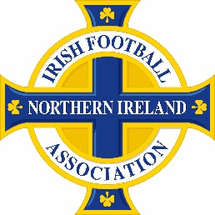
To represent Northern Ireland in international football, you need to meet specific eligibility criteria set by FIFA and the Irish Football Association (IFA). Here are the main ways to prove your eligibility:
- Birth: You were born in Northern Ireland.
- Parentage: You have at least one parent or grandparent who was born in Northern Ireland.
- Residence: You have lived in Northern Ireland for at least five years after reaching the age of 18.
- Nationality: You hold British or Irish nationality, which can be obtained through birth, descent, or naturalization
What documents do I need to provide
- Birth Certificate: If you were born in Northern Ireland.
- Parent's or Grandparent's Birth Certificate: If your eligibility is through parentage or grandparentage. Along with the grandparents birth certificate the parents birth certificate must be supplied to show the link.
- Proof of Residence: If you have lived in Northern Ireland for at least five years after turning 18. This could include utility bills, rental agreements, or official letters.
- Passport: To confirm your nationality (British or Irish).
- Naturalization Documents: If you obtained nationality through naturalization.
*birth certificates must always be the long version

