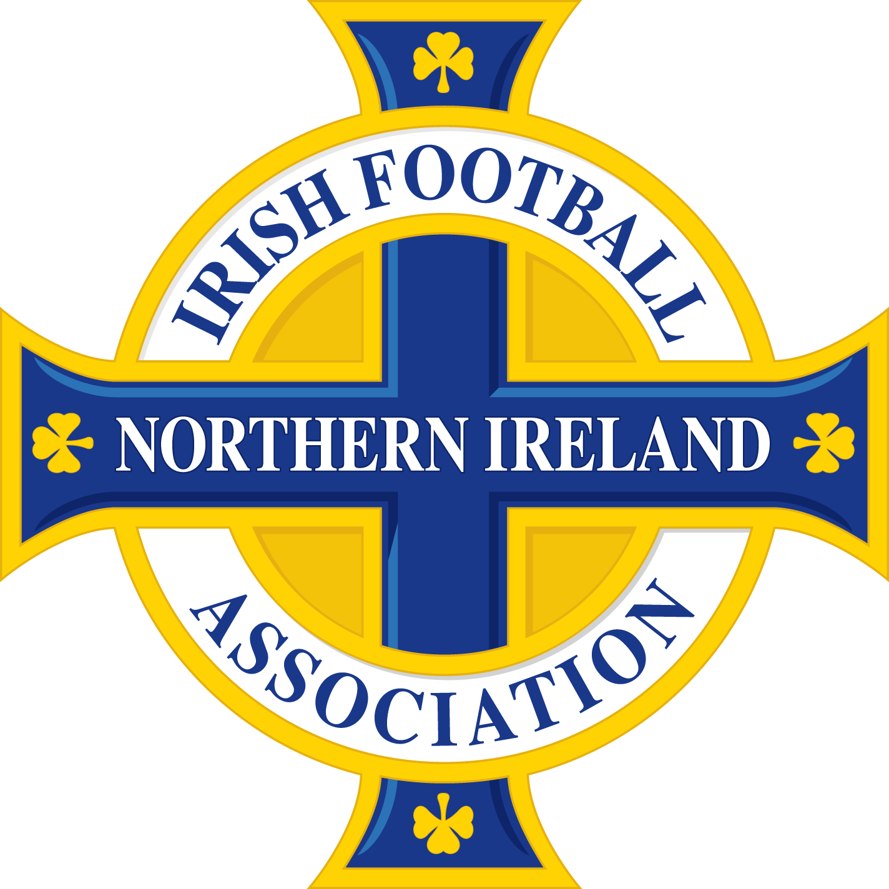

JOB DESCRIPTION

Job Title: Irish FA/UEFA Academy Head Coach

Location: National Football Stadium, Belfast

Responsible to: Head of Irish FA/UEFA Academy

Salarybracket: 26-35k

Hours of work: 35 per week (will include unsociable hours and over night stays)

Role family: Professional

Duration of Post: Permanent

PURPOSE OF THE JOB:

Managing the development and performance of players, technical and tactical lead on pitch for the Academy/Club NI programme. Manage and develop Talent ID framework nationally for boys Under 16. Support in the delivery of the Elite Player Performance Plan (EPPP)

MAIN DUTIES AND RESPONSIBILITIES:

- Lead and manage

  - All Academy/Club NI tactical and technical practice.
  - Regular reporting on all these programmes, games, and training schedules.
  - Player performance plans and reviews
  - Coach performance plans and reviews
  - Games programme for U16 Victory Shield
  - Parent/guardian reports and meetings

- Develop and manage a fit for purpose Talent Identification (ID) system nationally for boys U16

- Managing Talent ID casual staff members and volunteers#
- Co-ordinate the Talent ID programme across Northern Ireland
- Support in the development of a Talent ID recording system

- Co-ordinate timetabling and manage all Academy/Club NI technical and casual staff members aligned to EPPP.

- Able to commit to overnight residential stays involving supervision of players/staff 1-2 days per week.

- Manage and monitor safeguarding and Covid-19 protocols and guidelines within the Academy/Club NI programme.

- Ensuring all players and staff are adhering to safeguarding policies and procedures at all times.

- Proactively participate in training and development opportunities, staff performance appraisals and reviews as required.

- Comply with Data Protection Policy with regard to safeguarding sensitive customer information at all times.

- Perform the job in accordance with the company’s policies and procedures, especially the Equal Opportunities and Harassment Policy and Procedure.

- Adhere to and actively support at all times all other company policies, procedures, processes and working practices, including adhering to best practice.

- Perform any other duties as may reasonably be required from time-to-time.

- Activley engage in Continous Personal Development (CPD) where needed in relation to the role.

This job description is not to be regarded as exclusive or exhaustive. It is intended
as an outline indication of the areas of activity and will be amended in light of the changing needs of the Association.

PERSONNEL SPECIFICATION

Criteria: | Essential: | Desirable:
1. Education & qualification | 1.1 Holds a valid, up-to-date UEFA Pro Licence; or is currently registered on a UEFA Pro Licence Course and commenced working towards accreditation. | 1.2 Third level qualification in a sports/coaching/performance related discipline or equivalent
2. Experience | 2.1 3 years experience as a coach in a football performance environment with results based outcomes.  2.2 Have experience in managing a team of coaches in a football performance environment.  2.3 Have experience in elite youth specific coaching/preparation of players. | 2.4 Have experience working on a range of relevant coaching software applications.  2.5 Experience in identifying talent in a football based performance environment.
3. Skills, knowledge & competencies | 3.1 Effective communication (both written and oral) and interpersonal skills, with the capacity to develop an innovative partnership in education, community and club sectors.  3.2 Be able to demonstrate strong computer literacy skills and proven competency in using Microsoft Office applications such as PowerPoint, Word, Excel and Outlook.  3.3 Knowledge of domestic NIFL leagues and competitions. | 3.4 Demonstrable thorough knowledge an understanding of the youth football player development pyramid in Northern Ireland. (Grassroots-international)  3.5 Understand components of the ‘Four Corner’ Model/holistic approach to player development.
4. Personal disposition | - A team player who can work on their own initiative, organise and prioritise work effectively with a high degree of self-motivation and enthusiasm.  - Flexible and adaptable with ability to stay overnight 1-2 nights per week.
5. Other requirements  (5.4-5.6 are post job offer) | 5.1 Proof of eligibility to work in the UK.  5.2 Have a valid passport allowing unrestricted international travel  5.3 Have a clean driving licence and access to a car for business use  5.4 Completion of a medical questionnaire demonstrating the ability to fulfil the Occupational Health requirements for the post and flag any reasonable adjustment required.  5.5 Two satisfactory employment references, one of whom should ideally be the current/most recent employer.  5.6 Enhanced Access NI checks with satisfactory clearance.

Please note that the Association reserves the right to implement some of all the desirable criteria for shortlisting purposes.

ADDITIONAL INFORMATION

Closing date: The closing date for the receipt of completed application is 12.00noon on 5 August 2021. Applications received after the closing date and time will not be considered.

Shortlisting: Only those applications which clearly demonstrate the requirements set out in the personnel specification will be shortlisted. Please note that the Association reserves the right to implement all or some of the desirable criteria in addition to the essential criteria for shortlisting purposes.

Interviews: Provisional interview date – week commencing 9 August 2021.

Offer of employment: Please note any offer of employment is subject to the receipt of two satisfactory employment references, proof of eligibility to work in the UK and proof of any required qualifications.

Reserve list: A reserve list of suitable candidates may be maintained for the purpose of any similar vacancies (temporary or permanent) that may arise within twelve months of the completion of the recruitment exercise.

Vetting: The Irish FA is committed to safeguarding and promoting the welfare of children and young people and expects all staff and employees to share this commitment. This role involves work with young people and is subject to Enhanced Access NI checks. Clearance through this system is required.

The Irish Football Association is an equal opportunities employer and welcomes applications form all sections of the community. All appointments will be made on the basis of merit.

Approved: July 2021

