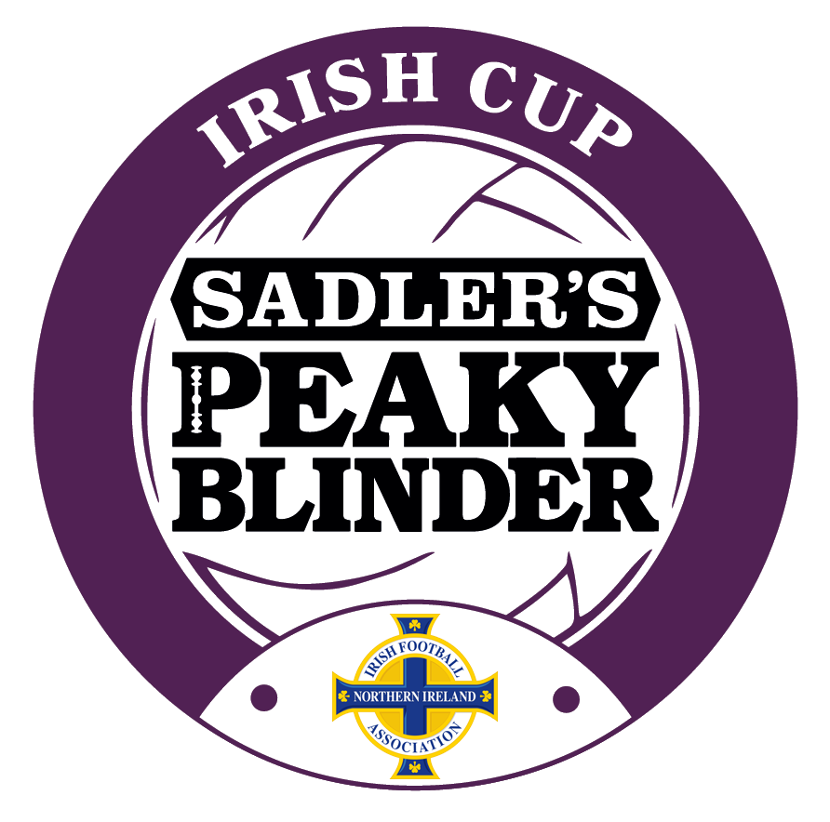
IRISH CHALLENGE CUP
ROUND 1
TO BE PLAYED TUESDAY, 27 APRIL 2021
KICK-OFF: 7.45 PM
(unless agreed otherwise)

1 | QUEEN’S UNIVERSITY  (withdrawn) | V | BANGOR *
2 | WARRENPOINT TOWN | V | BALLYCLARE COMRADES
3 | ARDS  (withdrawn) | V | DOLLINGSTOWN *
4 | COLERAINE | V | CRUSADERS
5 | GLENAVON | V | DUNGANNON SWIFTS
6 | H&W WELDERS  (withdrawn) | V | ST. JAMES SWIFTS *
7 | INSTITUTE  (withdrawn) | V | PSNI *
8 | KNOCKBREDA  (01.05.21 – KO: 2.30pm) | V | NEWINGTON
9 | LOUGHGALL  (01.05.21 – KO: 3.00 pm) | V | BANBRIDGE TOWN
10 | BALLINAMALLARD UNITED  (01.05.21 – KO: 3.00pm) | V | DERGVIEW
11 | CLIFTONVILLE | V | PORTSTEWART
12 | LINFIELD | V | ANNAGH UNITED
13 | LARNE * | V | NEWRY CITY  (withdrawn)
14 | GLENTORAN * | V | DUNDELA  (withdrawn)
15 | BALLYMENA UNITED | V | PORTADOWN
16 | CARRICK RANGERS | V | BELFAST CELTIC

*Those teams who have decided to withdraw from the competition - their opponents receive a walkover to R2*

