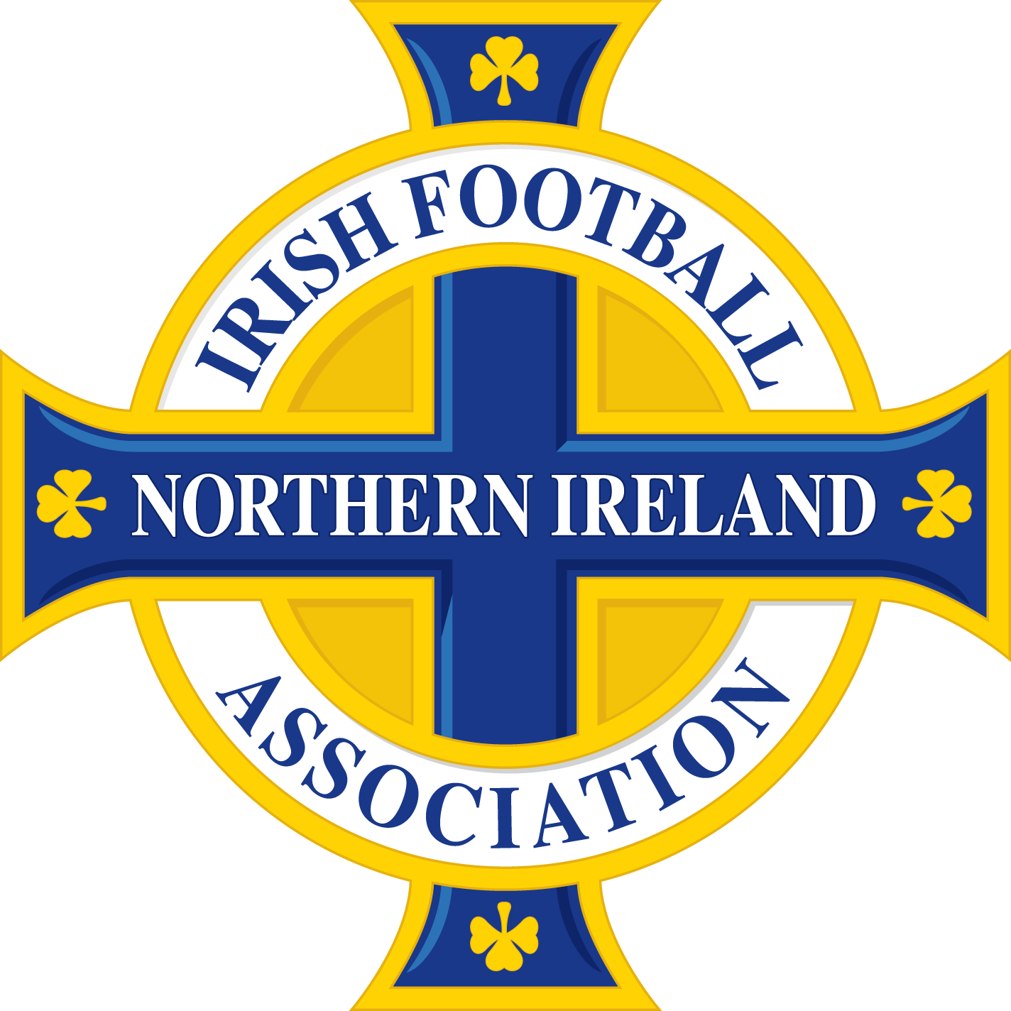

ROLE DESCRIPTION

Placement Title: Commercial Events Placement

Location: National Football Stadium at Windsor Park, Belfast

Responsible to: Commercial Events Officer

Duration of Post: September 2020 – August 2021

PURPOSE OF THE ROLE

To support and assist the Commercial Events Officer and other IFA staff in the delivery of Commercial Events within the National Football Stadium including Irish FA Tours, Corporate Hospitality and Non-Football events.

MAIN DUTIES AND RESPONSIBILITIES:

- Support the Commercial Events Team in relation to the IFA Education and Heritage Centre and Stadium Tours with specific focus on the following areas:

  - Administrative support to the Education and Heritage Centre, including the development of Rota systems, dealing with external bookings and developing EHC risk assessments
  - Supervision of EHC volunteers during events and stadium tours
  - Assist in the updating of the EHC online booking system
  - Assist in the delivery of volunteer development training, talks and promotional campaigns
  - Liaising with other key parties within the stadium in relation to Stadium access and usage for Tours
  - Providing excellent communication and updates to public enquiries, volunteers and other stakeholders

- Supporting the development and documentation of the full Commercial Events offering for 2020/21 including Stadium Tours, Special Events and Corporate Hospitality.
- Support the identification and implementation of approved options for resourcing the offerings from the EHC items such as branding, and props required for the tour etc…
- Support the ticketing and bookings at the centre dealing with public enquiries and processing bookings within the EHC.
- Support the Commercial Events Officer in managing the IT booking system including customer relations management.
- Dealing with Birthday party bookings and reservations
- Liaise with catering partner Sodexo re corporate catering bookings.
- Liaise with the Irish FA Education department to develop educational programmes and schools’ bookings and programmes.
- Support the effective management of Health & Safety risks and issues in conjunction with the Commercia Events Officer;
- Support the maintenance and upkeep of all exhibits in the EHC in conjunction with third party suppliers;
- Update, manage and develop a range of volunteer recruitment and management resources including volunteer supervision records.
- Support and update the content of the EHC’s microsite and social media channels.
- Promote events and opportunities when needed through the development of Press Releases and use of other promotional methods
- Ensure that all relevant programmes and activity information is documented, collated and analysed so that progress towards outcomes can be demonstrated internally and externally.
- Work closely with IFA staff to support the implementation of the IFA Strategy
- Support the Commercial Events Officer in the preparation of funding applications, reports and programme evaluations.
- Adhere to and actively support at all times all company policies, procedures, processes and working practices, including adhering to best practice.
- Any other duties as may be reasonably requested from time to time.

Essential Requirements
- Excellent administration skills
- Excellent communication skills especially written, and oral
- Ability to follow standardised processes
- Reliable and trust worthy
- Ability to present to and lead visitor groups

Desirable Requirements
- Experience in admin based roles
- Experience in updating website content
- A valid driving license with access to a car/van

Salary Details
This opportunity with the Irish FA is an unpaid placement however it is anticipated that Out of Pocket Expenses will be paid. The placement role will also include a number of training and development opportunities.

