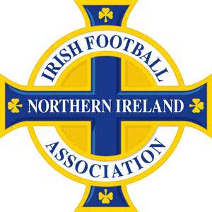

IFA Volunteer Recognition Scheme
The Irish FA volunteer programme was developed in September 2014 to support the new EURO 2016 Qualifying campaign. Since then it has grown rapidly and is now a nationally recognised volunteer programme. As part of the Irish FA Volunteer Policy and Programme there is a clear need and desire to recognise the value, efforts and enthusiasm that volunteers have brought to the association. As such a uniform volunteer recognitio0n scheme has been established to do so.
Bronze | Silver | Gold | Platinum
25 hours | 50 hours | 100 hours | 200 hours
Official Irish FA 25 hour Certificate  Behind the scenes tour of the National Stadium  Access to free workshops, events and training opportunities | Official Irish FA 50 hour Certificate  Free Volunteer T shirt  £20 towards an Irish FA training course | Official Irish FA 100 Hour certificate  Free Volunteer Polo Shirt  £40 towards an Irish FA Training Course | Official Irish FA 200 hour certificate  Official Website and Social media Recognition  £75 towards an Irish FA Training course  2 x NI match tickets
How it works
Volunteers should record their volunteer hours using the online log book format provided. They should then notify the Irish FA Volunteer Development and Policy Officer when they feel they have achieved one of the achievement levels. Hours are cumulative and there is no time restrictions.
Other benefits
As well as the above benefits, Irish FA volunteer Team members can access the following generic and existing benefits:
- Official CV endorsement
- Character / Employment References
- Networking opportunities
- Pathways to employment and personal development opportunities
- Invitation to the Annual Volunteer Recognition event (if the volunteer has achieved a level within the preceding year)
Eligibility
All Irish FA Volunteer Team members are eligible for this volunteer recognition scheme.
Terms and Conditions
This scheme is governed by terms and conditions which will be shared with all volunteers when joining the Irish FA Volunteer Programme and upon request by any volunteer.
More Information
If you would like more information on this scheme or about Volunteering at the Irish FA, please contact Stephen Garrett, Irish FA Volunteer Development and Policy Officer, Unit B Adelaide Business Centre, 4 Apollo, BT12 6HP or via sgarrett@irishfa.com l 07545930124

