 In association with 

Finishing cont:

Scoring goals is the ultimate aim of football and to do so within a game, players require many different qualities such as skill, imagination pace and strength, awareness and composure.
Without the ability to finish well in front of goal any team will find it very difficult to score goals and subsequently win matches.

Finishing is a key part of the game and can be used in training to not only sharpen your player’s abilities in front of goal but also as a means of conditioning.

Furthermore, all players love scoring goals and are generally motivated to work harder when doing so.

Continuing with our theme of Finishing, we have included a progression to the “One Touch Passing Drill” that was in last month’s Newsletter as well as a fun, small sided game that requires both speed of thought and movement, giving your players lots of opportunities to practice their finishing skills.

Insights that you can give your players are:

- “With a clear sight at goal…be direct, attack the goal at pace.”

- “Look up early to assess where the Goalkeeper is… see how are they moving?”

- “Can you fake or disguise your movement to wrong foot the Goalkeeper?”

- “Can you create half a yard of space for yourself to receive the ball by making a fake movement away first?”

- Passes within the build up need to be sharp and accurate and combined with sharp and quick movements

The games below will help to develop your players’ attacking technique.

One-Touch Passing & Finishing Part 2

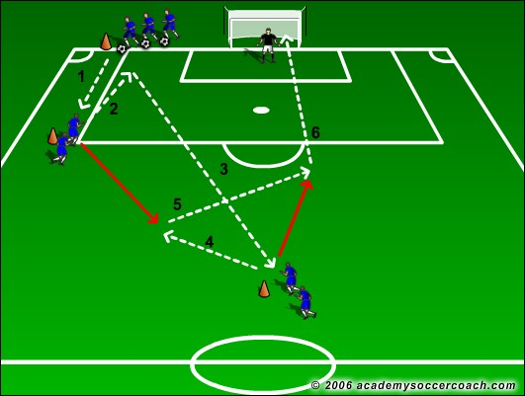

Click on image to view and download.

“21” 4v4 Game

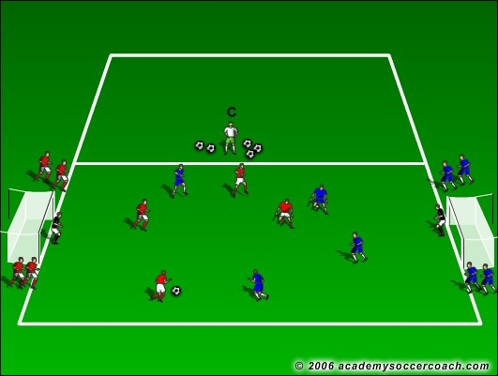

Click on image to view and download.

For more 1v1 Practices and Games click onto the link below where you can purchase our exclusive coaching journals covering:
- 1v1 Practice Games
- 4v4 Games Part 1
- 4v4 Games Part 2
- Build-Up and Multi-Finishing Drills

Fully proven at both elite and grassroots levels....our instantly downloadable PDF Journals contain up to 30 proven practices and games which are fully illustrated and come with easy to follow instructions. Each practice has been specifically designed to help you to develop your players whilst still having FUN from actually playing the game.

Click on the images below to order your copy now and have a fresh, “game based” practice to hand for every training session!

