 In association with 

The importance of 1v1s in Football Part 3:

Continuing our theme of 1v1 situations, we’ll now take a look at some of the key aspects of attacking in 1v1 situations.
Let’s recap the key attacking insights from the 1st article.

Attacking Insights that you can give your players are:

- “Try to slow the defender down and then accelerate”
- “All you need is half a yard”
- “Take the defender away from where you want to go, this will give you the space to attack”
- (For example a right footed player would take a defender to the left, before accelerating quickly into the space created on the right)

“Try to slow the defender down and then accelerate”.

By slowing the defender down you will be able to use the element of surprise along with a “skill” or “trick” such as a “scissors” or “step-over” etc to unbalance the defender and create the opportunity to accelerate away.

“All you need is half a yard”.

You only need to create a half yard “head start” for yourself to accelerate away and leave the defender behind you.
Remember to “shut-out “the pursuing defender by running across their path.

“Take the defender away from where you want to go this will give you the space to attack”.
If you are right-footed then you will want to create space on your right to attack, giving you an opportunity for a shot with your stronger foot.
To do this you would take the defender to your left….this will automatically create the space to your right for you to exploit.
If you are left-footed then the opposite would apply.

The games below will help to develop your players’ attacking technique.

1v1 DISGUISE

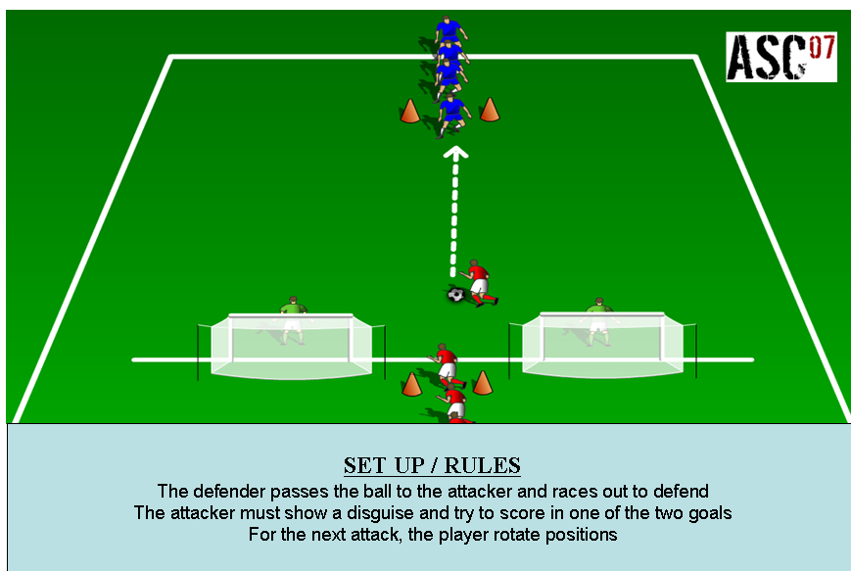

1v1 LOSE THE DEFENDER

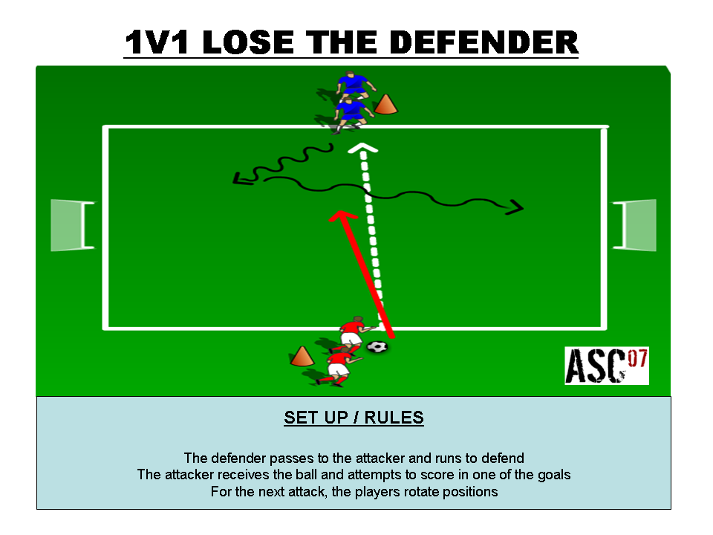

Click on the images above to download

For more 1v1 Practices and Games click onto the link below where you can purchase our exclusive 1v1 Games Coaching Journal. This instantly downloadable PDF Journal contains 25 fully proven practices and games which have been specifically designed to encourage your players to develop both their technique and decision making skills in order for them to come out on top.

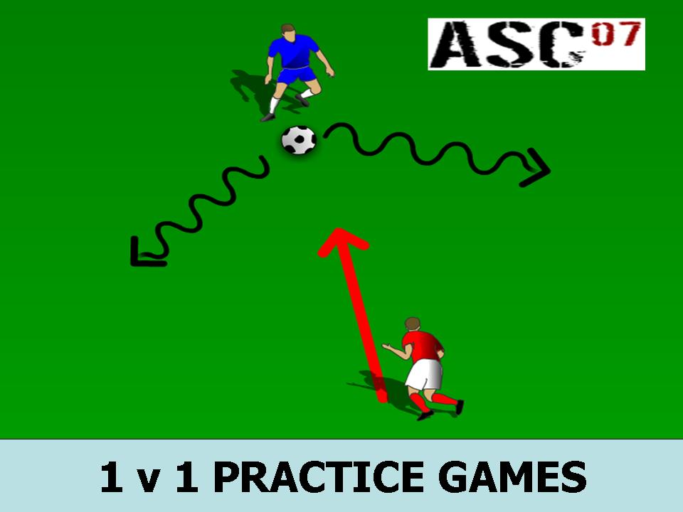

Click onto the image above to get your copy now!

