 In association with 

The importance of 1v1s in Football Part 2:

Continuing our theme of 1v1 situations, we’ll now take a look at some of the key aspects of defending in 1v1 situations.

Let’s recap the defending insights from the previous article:

In Defence –

- “Close the space”
- “Show away from danger or towards a team-mate”
- “Force the opponent to play backwards or sideways”
- “Be patient and stay on your feet”
- “If you delay the attacker for 3-5 seconds then you will have given
your team mates enough time to recover and support you”.

“Close the space”.

When defending, close down the player in possession quickly, taking care to slow down on the last few yards of your run.
Closing down the space quickly enables you to delay the attacker, gaining valuable seconds for your team mates to recover and support you.
This will also quickly limit the options available to them, pressurizing them to play backwards or sideways…or better still make a mistake!

“Show away from danger or towards a team-mate”.

This really depends whereabouts on the pitch the situation is taking place.
For instance, when defending centrally, outside of your penalty many coaches will ask you to show or “steer” the attacker towards the flank where there is less danger, rather than inside towards your goal.
Alternatively, if defending in a wide area, further up the pitch you might want to show or “steer” the player inside towards a team mate rather than letting them attack down the flank.

“Be patient and stay on your feet”.

It’s really important that when defending we don’t “dive-in” and potentially commit a foul. Instead we need to stay on our feet…be patient,” jockey” the attacker and keep them in front of us...by doing this we delay the attacker and give our team mates valuable time to recover and support.

Remember that every player is a defender when we don’t have the ball!

The games below will help to develop your players’ defending technique.

1v1 DEFEND YOUR GOAL

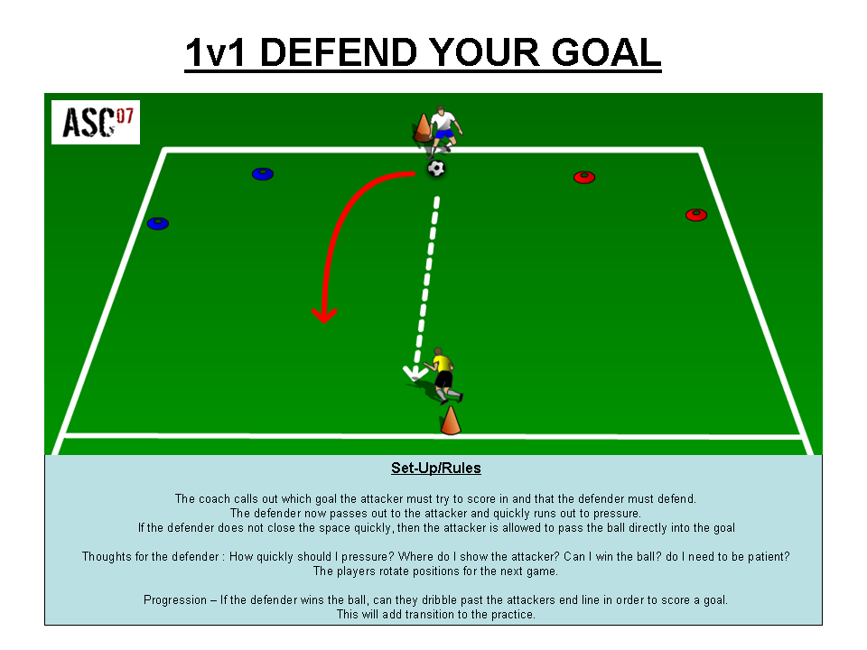

1v1 CONTINUOUS GAME

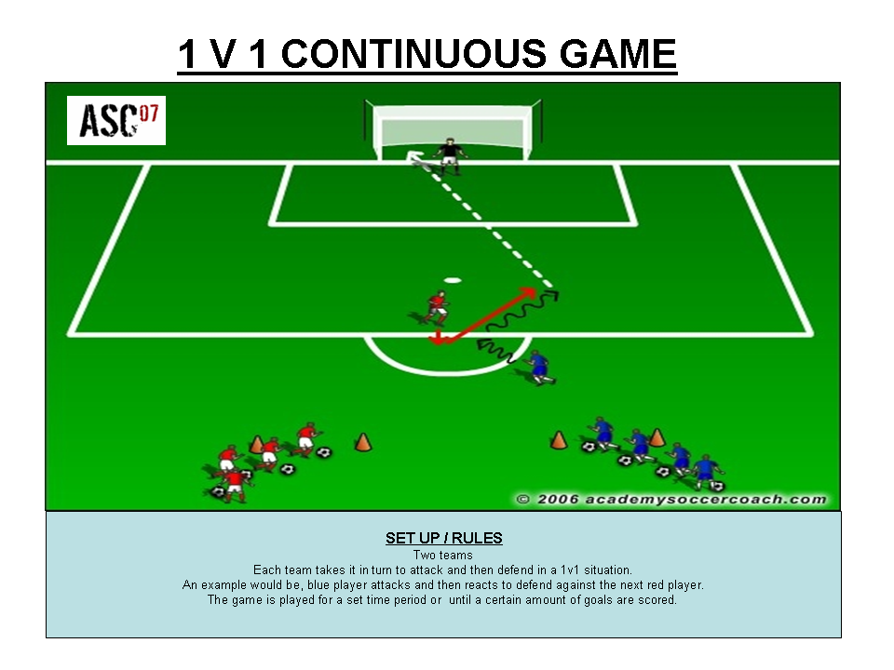

Click on the images above to download

For more 1v1 Practices and Games click onto the link below where you can purchase our exclusive 1v1 Games Coaching Journal. This instantly downloadable PDF Journal contains 25 fully proven practices and games which have been specifically designed to encourage your players to develop both their technique and decision making skills in order for them to come out on top.

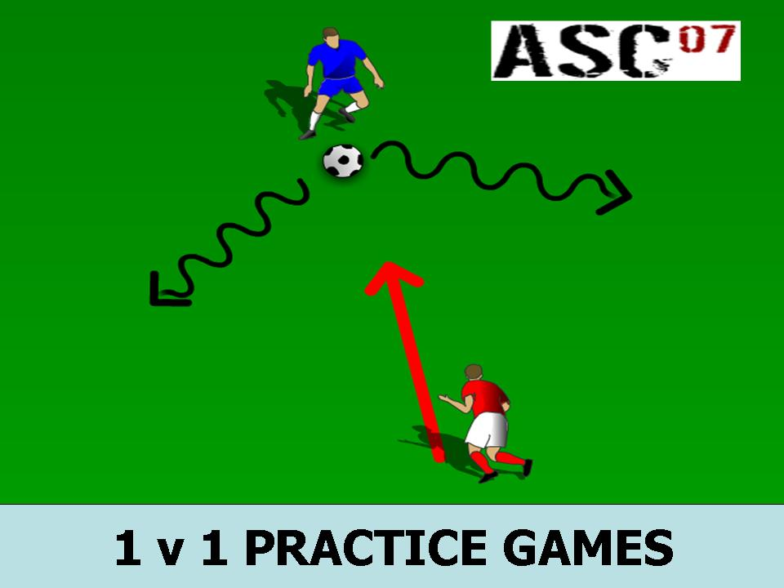

Click onto the image above to get your copy now!

