 In association with 

Defending Overloads:

Following on from the previous session on creating and exploiting overloads in attack, we will now focus on defending overload practices.

Overloads are situations that arise in a game where one team has the advantage of having more players around the ball than the other, therefore creating a 2v1, 3v2 or 4v3 etc situation.

The first overload practice below will see your defenders start off against an overload but then gain a recovering defender to make the practice even.

The second practice sees the one team with a consistent overload advantage, both in attack and defence.

Finally, your defenders will find that they initially have the overload advantage, but this is decreased as the practice continues, challenging them to react quickly and adapt to the constantly changing situation.

The games below will help to develop your players’ attacking technique.

2v1 + RETREATING DEFENDER

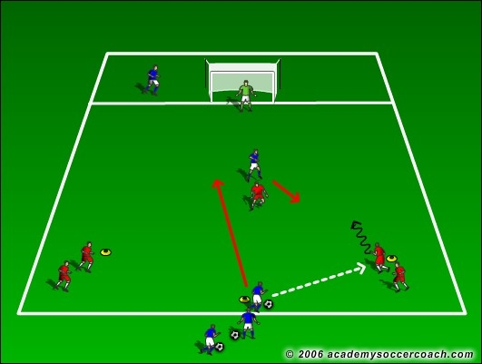

Click on image to view and download.

2v1-1v2 CONTINUOUS GAME

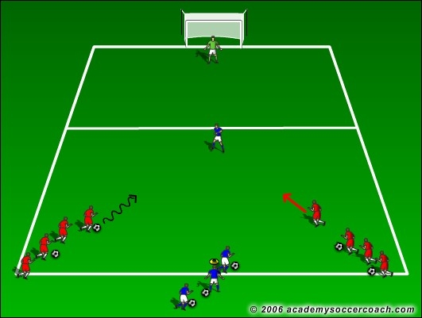

Click on image to view and download.

DEFENDING OVERLOAD GAME

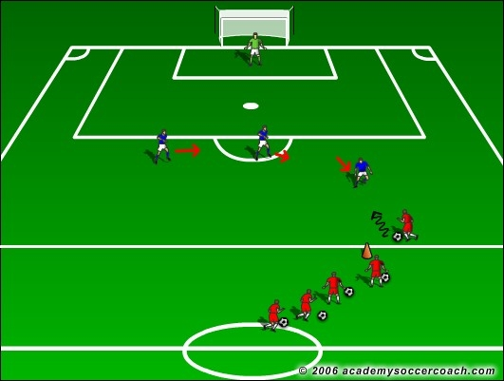

Click on image to view and download.

For more 1v1 Practices and Games click onto the link below where you can purchase our exclusive 1v1 Games Coaching Journal. This instantly downloadable PDF Journal contains 25 fully proven practices and games which have been specifically designed to encourage your players to develop both their technique and decision making skills in order for them to come out on top.

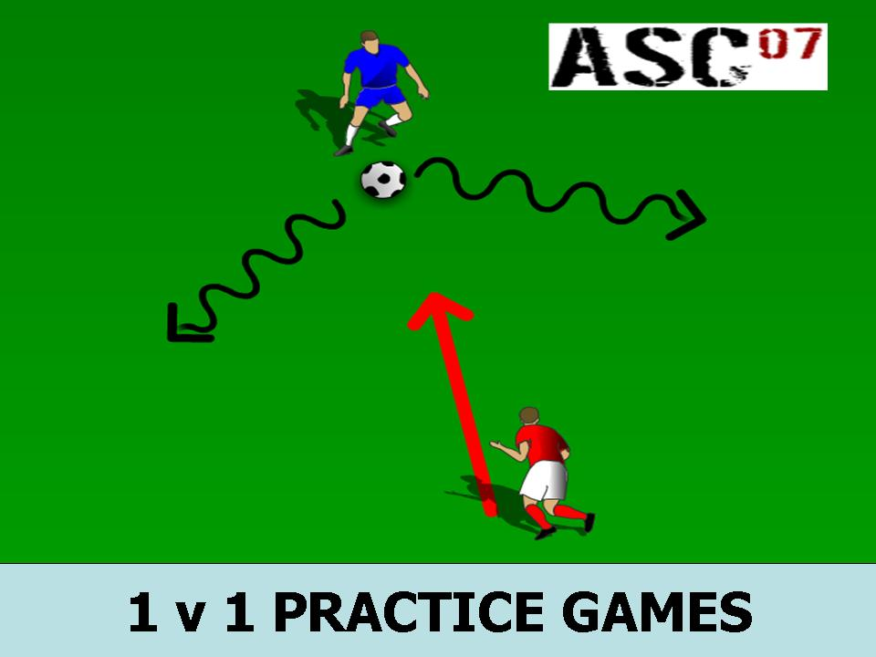

Click onto the image above to get your copy now!

