 In association with 

Overloads in Transition:

Following on from our 2v1 overloads in defence and attack we are now going to focus on exploiting overload situations that occur during a period of play in a game known as the “Transition”.

The “Transition” (transition of play) is the moment within a game where possession of the ball changes from one team to the other.
Obviously this can take place all over the pitch and it is therefore important that players can recognise and react quickly to these situations, exploiting any advantages that appear.

These practices will help you to develop the awareness and reaction speed of your players within transition situations.

The first practice below forces your players to make their own choices and react quickly to attack and defend the goal.

The second practice sees a continuous attacking and defending game where transition occurs constantly.

Finally, your players will need to respond quickly as transition occurs in order to maximise their overload advantage.

The games below will help to develop your players’ attacking technique.

2v1 CHOICE

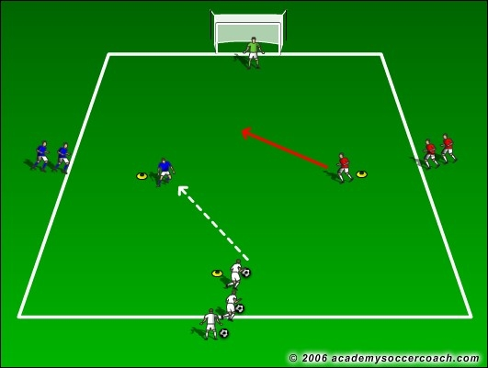

Click on image to view and download.

2v1 CONTINUOUS

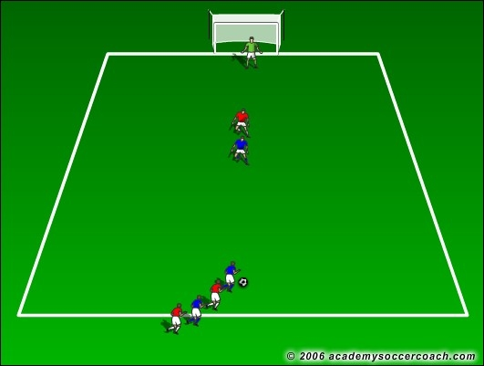

Click on image to view and download.

1v2-2v1 COUNTER ATTACK GAME

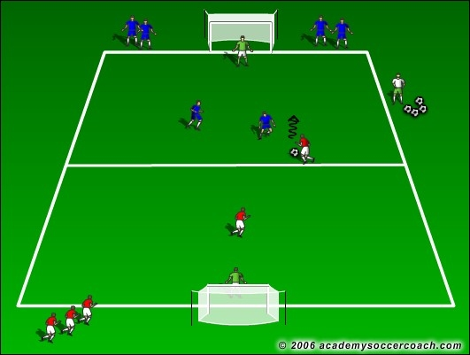

Click on image to view and download.

For more 1v1 Practices and Games click onto the link below where you can purchase our exclusive coaching journals covering:
- 1v1 Practice Games
- 4v4 Games Part 1
- 4v4 Games Part 2
- Build-Up and Multi-Finishing Drills

Fully proven at both elite and grassroots levels....our instantly downloadable PDF Journals contain up to 30 proven practices and games which are fully illustrated and come with easy to follow instructions. Each practice has been specifically designed to help you to develop your players whilst still having FUN from actually playing the game.

Click on the images below to order your copy now and have a fresh, “game based” practice to hand for every training session!

