 In association with 

The importance of 1v1s in Football

It’s vitally important that players are able to attack and defend in 1v1 situations.
Many people hold the opinion that if a player is unable to do this then they shouldn’t be given a place on a team.
Coaches often accelerate into small games of 3v3, 4v4, 5v5 etc without spending adequate time on the basic attacking and defending principles.

1v1 practice games are an essential component of any training programme and vital to a coach as this situation occurs naturally in any game. Players must feel comfortable dealing with these situations and finding a solution whether they are in attack or defence.

Insights that you can give your players are

In Attack –

- “Try to slow the defender down and then accelerate”
- “All you need is half a yard”
- “Take the defender away from where you want to go, this will give you the space to attack”
- (For example a right footed player would take a defender to the left, before accelerating quickly into the space created on the right)

In Defence –

- “Close the space”
- “Show away from danger or towards a team-mate”
- “Force the opponent to play backwards or sideways”
- “Be patient and stay on your feet”
- “If you delay the attacker for 3-5 seconds then you will have given
your team mates enough time to recover and support you”.

1v1 DISGUISE

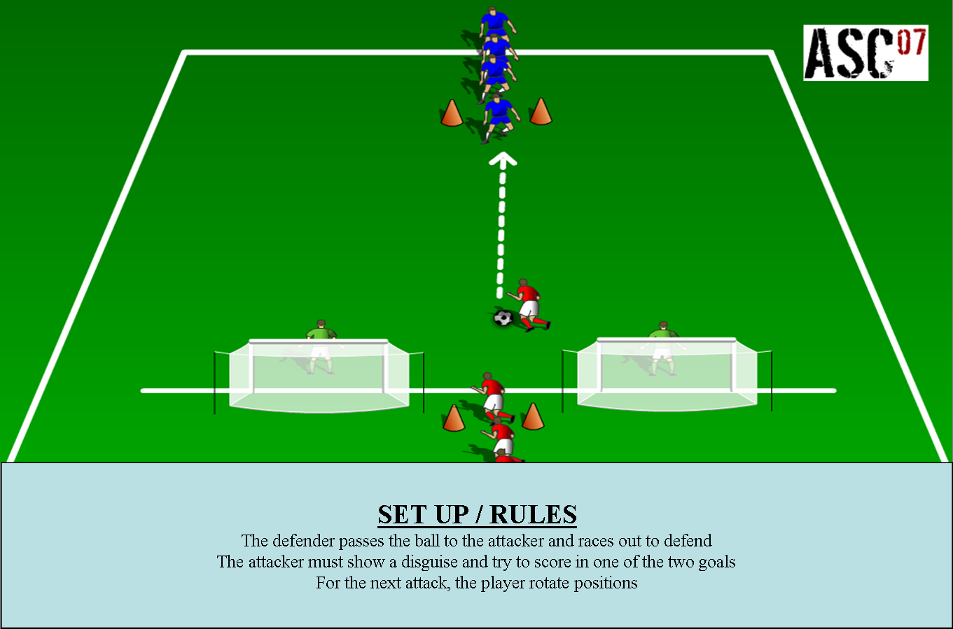

1v1 PENALTY AREA

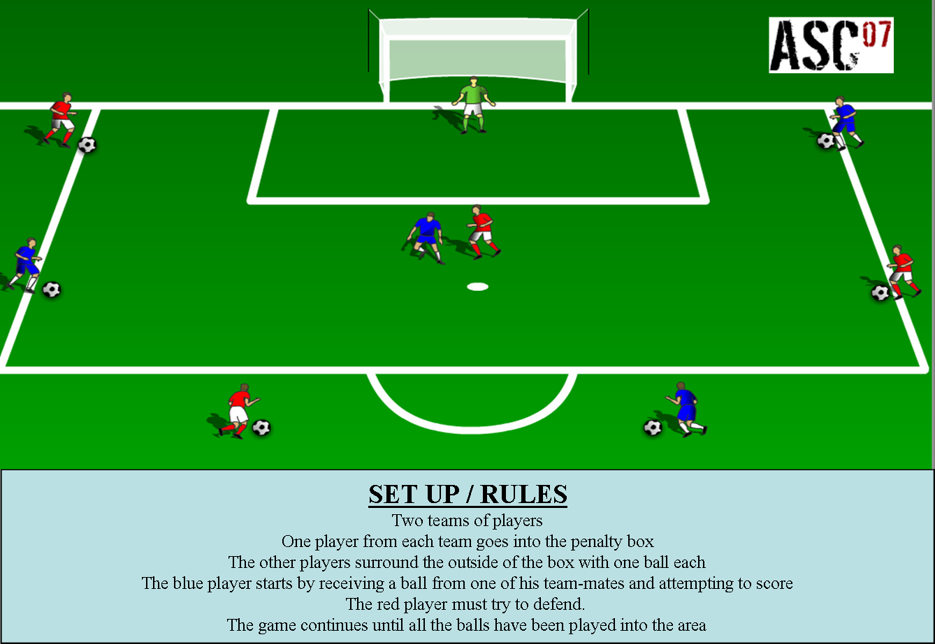

Click on the images above to download

For more 1v1 Practices and Games click onto the link below where you can purchase our exclusive 1v1 Games Coaching Journal. This instantly downloadable PDF Journal contains 25 fully proven practices and games which have been specifically designed to encourage your players to develop both their technique and decision making skills in order for them to come out on top.

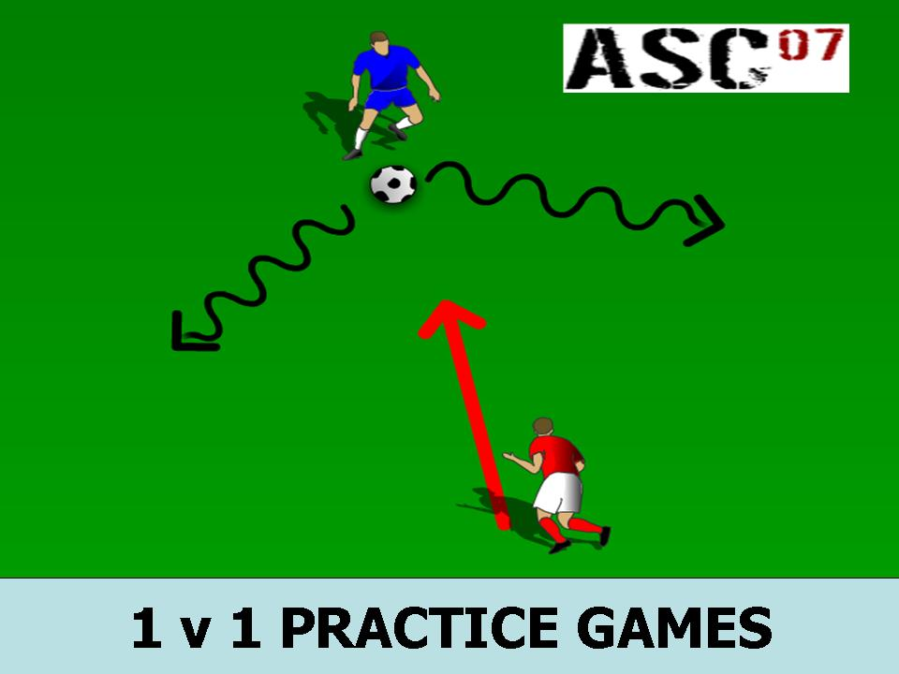

Click onto the image above to get your copy now!

