**Applications open for Irish FA / UEFA Pro Licence Diploma Course 2017/2018**

Applications are now being sought for the upcoming Irish FA UEFA Pro Licence Diploma Course due to commence on Monday 15 May 2017

The highest coaching qualification in Europe, the UEFA Pro Licence Diploma Course is now a mandatory requirement to manage in the NI League, other European leagues and UEFA Club and International competitions

Candidates must hold the UEFA ‘A’ Licence

The course will involve 500 contact hours over circa. 18-month period

**UEFA Pro Licence Competencies:**



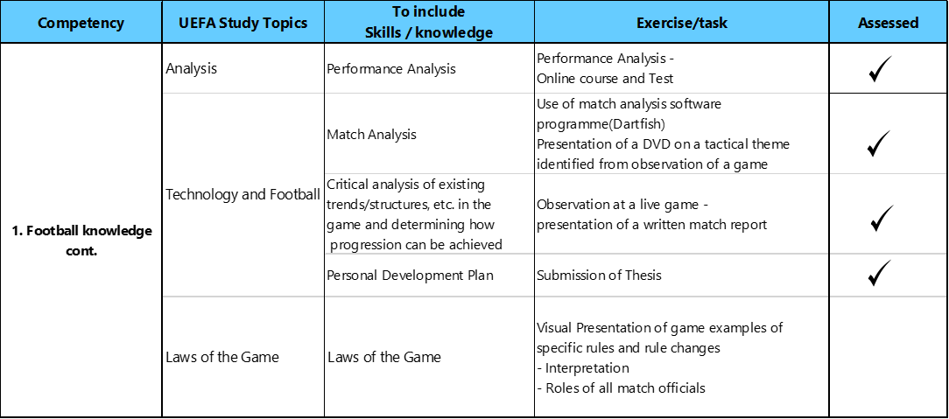







**Irish FA / UEFA Pro Licence Hours**



**Irish FA / UEFA Pro Licence Diploma Course Application Process**

All applications received by the closing date of **5.00pm on WEDNESDAY 23 NOVEMBER 2016** will be considered.

The UEFA Pro Licence is an elite coaching qualification intended, by UEFA, only for those coaches who are currently, or who have the potential to be, working at the top professional leagues, clubs or at International level. It is not intended to be sought by coaches as an extra qualification to add to their CV if they have not the intention to work at elite competitions level. If it is not your intention, or if it’s unlikely you will have the opportunity, to work at elite professional level, we would encourage you to find alternative courses and learning opportunities to extend your CV and improve your football knowledge without necessarily pursuing the UEFA Pro Licence.

**Applicants must submit the following:**

* Application Form (on page 5)
* A short CV (no longer than 2 x A4 pages) to include:
  + Coaching experience
  + Playing experience
  + Why it is important to your career to be accepted onto the upcoming Pro Licence with the Irish FA
* For those coaches who have not obtained their UEFA A Licence through the Irish FA, you must provide evidence that they have a valid UEFA A Licence

**Selection and Notification**

An Irish FA selection panel comprising of the Elite Performance Director, Coach Education Manager and NI Women’s International Manager will consider all applications.

All applicants will receive notification of whether they have been offered a place via email no later than Wed 30 November 2016

Furthermore, the Irish FA has to submit the list of names of successful candidates to UEFA for their approval.

Once all processes have been concluded, successful candidates will be required to sign an acceptance contract which will specify Terms and Conditions, including specific dates for payment of course fees and confirmation of full attendance irrespective of club commitments

(Please confirm with your club that it will support this attendance commitment)

**Terms and Conditions**

* Applicants will be asked to abide by the Irish FA Coach Education Code of Conduct
* Correspondence for the UEFA Pro Licence course will be done via email. Therefore, please ensure you complete the email field on the application form and that you have access to an active email address
* No refund of fee will be made by the Irish FA to the applicant if the applicant fails to attend the commencement of, or complete the Irish FA / UEFA Course

**Irish FA / UEFA Pro Licence Diploma Course 2017-2018 Application Form**

|  |  |
| --- | --- |
| **First Name** |  |
| **Surname** |  |
| **Date of Birth** |  |
| **Place of Birth** |  |
| **Nationality** |  |
| **Address** |  |
| **Post Code** |  |
| **Email address** |  |
| **Mobile contact number** |  |
| **Origin of ‘A’ Licence** |  |
| **Date of issue of ‘A’ Licence** |  |
| **Current Club** |  |
| **Position Held** |  |
| **Adidas Size (S/M/L/XL)** | **Please note we cannot ‘mix and match’ sizes |

**Course Fees and payment details**

**Course fee: £6500.00**

First instalment: £4000.00 to be paid on acceptance onto the course

Second instalment: £2500.00 to be paid no later than Friday 12 May 2017

**Declaration by the applicant**

By signing this application form I agree that:

1. The information I have provided is accurate;
2. I have read and accept the T&C’s and I understand they will form part of the contract with the Irish FA, if my application is accepted

Signature of applicant: ___________________________________________________________________

Date: ___________________________________________________________________

***Please return (Hard Copy) of the signed application form and full dossier***

***No later than 5.00pm on Wed 23 November 2016 to:***

**Lorna Stewart**

**Coach Education Administrator**

**Irish Football Association**

**National Football Stadium**

**Donegall Ave, Belfast**

**BT12 6LW**